- Purpose
  - The purpose of this document is to describe the procedure for final assembly on the Genesys 20, Pad Assist machine.
- Scope
  - This SOP applies to all equipment assembly team members. The process applies to all machine ID’s:
- Responsibilities
  - The operations manager/supervisor is responsible for enforcing this SOP.
- Materials
  - The proper materials needed for this process are listed on the machine work order.
- Definitions

- Procedure
  - Place a frame (SOP EQ 144) and disk head (SOP EQ 121) onto a build cart.
  - Flip the disk head upside down so that the bottom is showing. Install a test pad driver onto it. Ensure that the pad driver is centered on the outer shroud and will not hit it. If it does, loosen the bolts on the shroud and re-center it so that the pad doesn’t hit. Tighten the bolts back up once complete. Flip the disk head back over so that it is sitting on the pad driver.

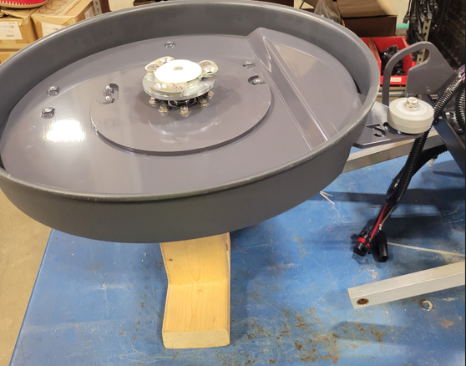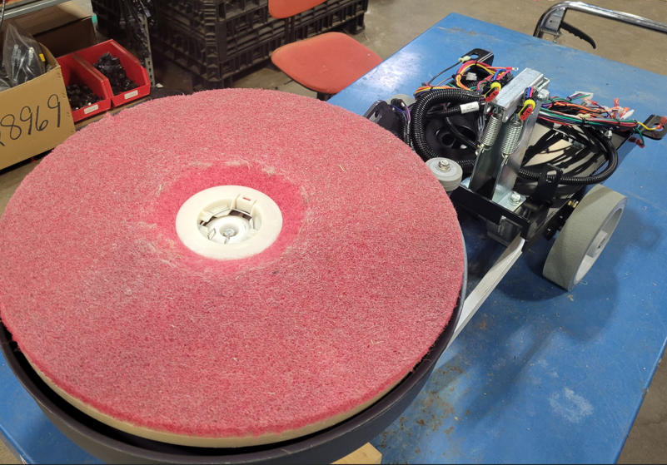

  - Line the disk head up with the frame. Use the two arms and the roller track as guides for alignment.
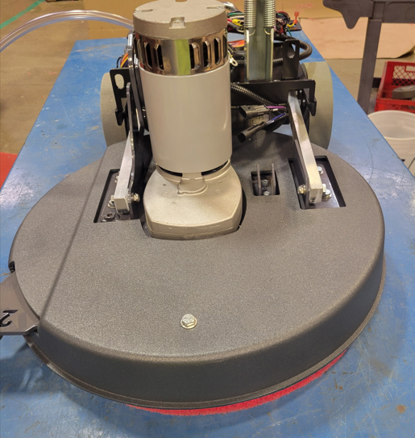
  - Place a bushing (E28693) into the bronze bushing that is in the end of each lift arm.
  - Attach each arm to the disk head using a bolt (E10112), 2 flat washers (E28622), a plastic washer (E83145), and a nylock nut (E28623). The plastic washer will go between the lift arm and the mounting bracket as shown. It should sit over the end of the bushing that was placed in the arm the previous step. One flat washer goes under the bolt head and the other goes under the nut.

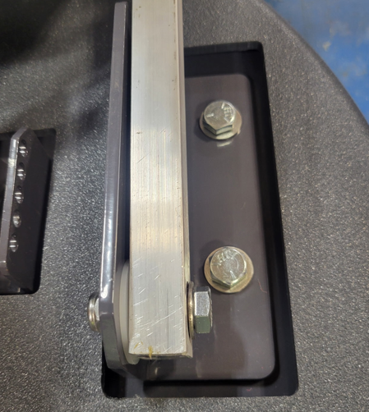

  - Place a bushing (E29019) into the roller wheel (E29012). Ensure that the mounting bracket is lined up with the roller track bracket. The roller track bracket should be loose, so it can be moved around slightly if needed. Attach the roller assembly using a bolt (E28694), 2 flat washers (E28622), and a nylock nut (E28623).

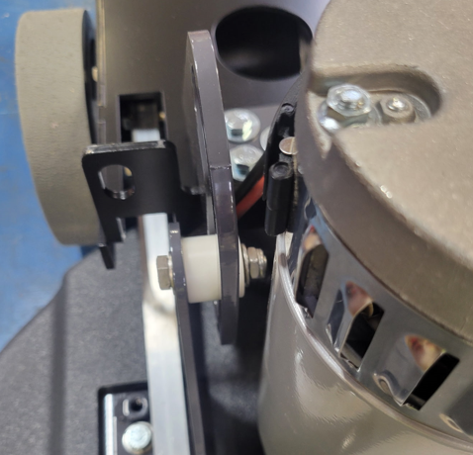
  - Move the roller track bracket so that the slot is centered on the roller. Thread in the jack screw until it touches off on the bent tab. Tighten the nut to hold it in place. This will set the location of the bracket.

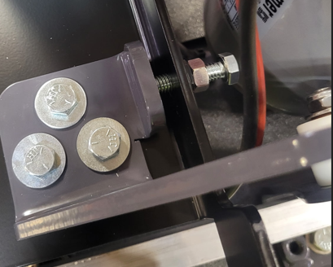

  - Tighten the three bolts that hold the roller track bracket. Ensure the bracket is square with the frame prior to doing this.

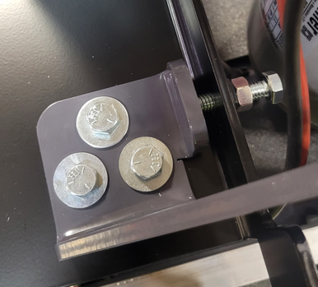

  - Place a solution tank assembly (SOP EQ 136) onto the table. Sit it so that the front of the tank is resting on the back of the frame. This way once everything is connected it can simply be slid forward prior to final attachment.
  - Feed the solution line from the pump through the frame opening shown. It should come out at the deck along with lift arm as shown.

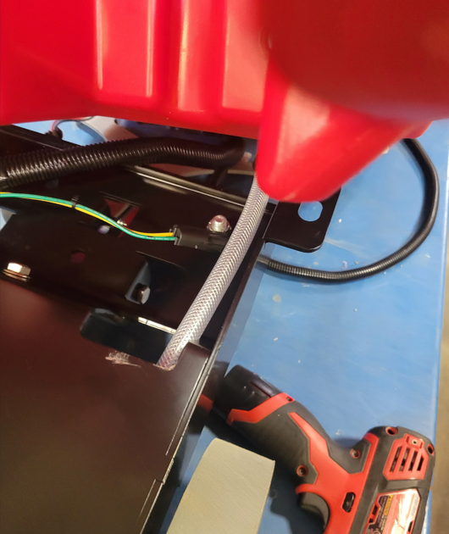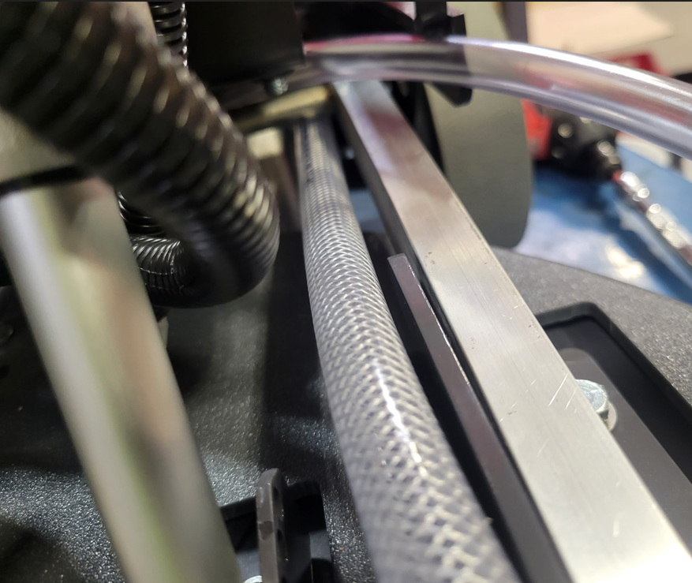

  - Connect the pump to the harness as shown. The connector from the harness has green and yellow wires.

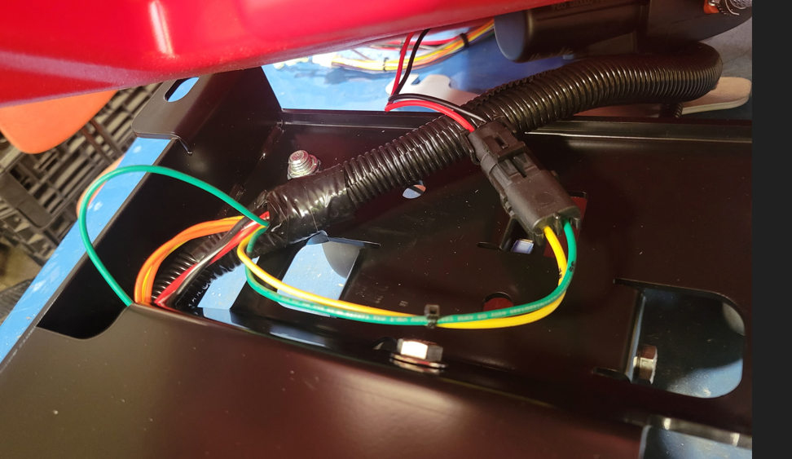

  - Slide the tank forward so that it sits on the frame. Ensure that the hoses and wires stay in a good position and do not get bound up.
  - The tank will come forward until it hits the two front flanges on the frame. Fasten the tank to the frame with 4 bolts (E81089). The two bolts on the front bent tabs get the E29403 washer while the two rear bolts get the E29388 washer. Use Blue Loctite on the bolt threads.

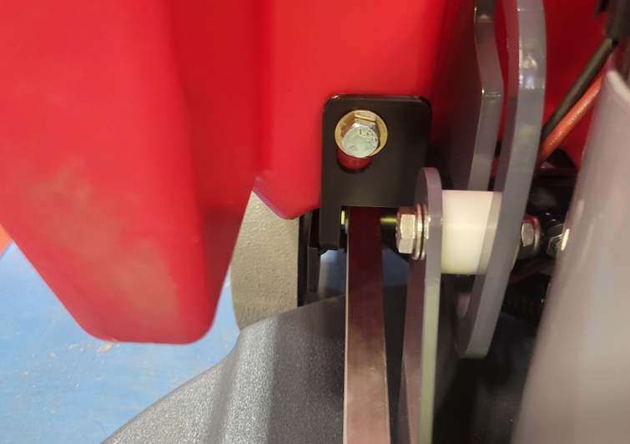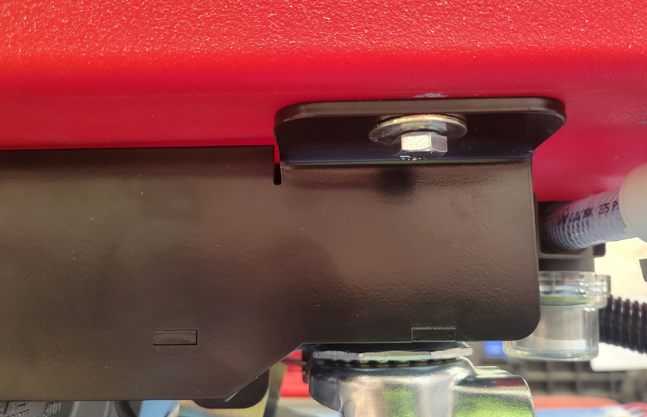
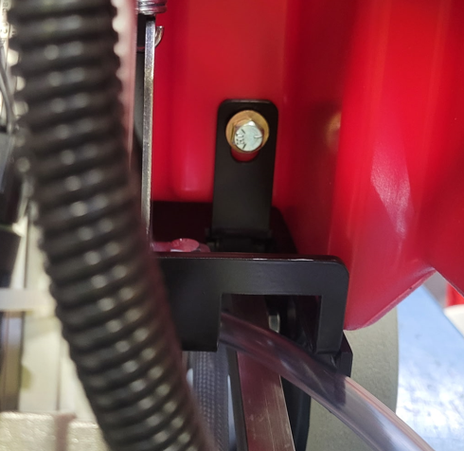

  - If the machine is to be equipped with Solichem, get a Solichem Cannister (SOP EQ 099) with a puck cage installed (SOP EQ 098), 2 Probe Assemblies (SOP EQ 101), and a TDS Board assembly (SOP EQ 102).
  - Take the Solichem cannister and place it into the pocket inside the solution tank.

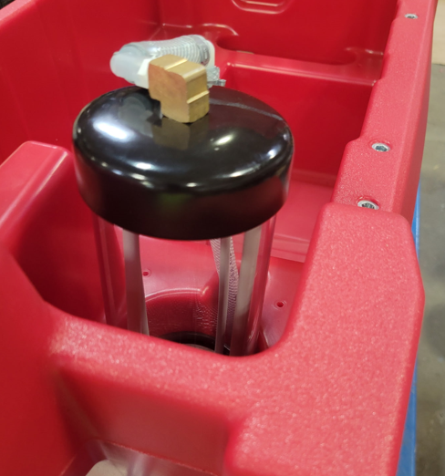
  - Connect the solution line from the pump to the inlet port on the cannister. Use a pinch clamp (E28773) to secure the end.

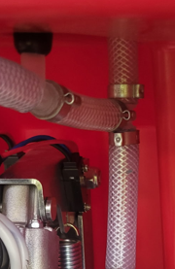

  - Cut the line approximately 3” from the connection that was just made. Take one of the TDS probe assemblies and attach it between the two cut ends. Use 2 pinch clamps (E28773) to secure it. Orient the probe as shown in the photo.

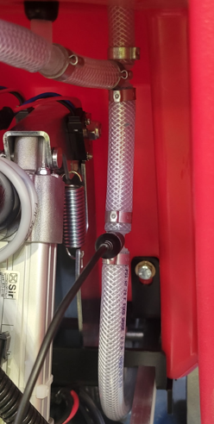
  - Cut a 6” piece of tubing (E28609) and connect it to the outlet port on the cannister. Press another probe assembly onto the other end. Then connect the other end of the probe to the clear tubing that connects to the scrub deck.

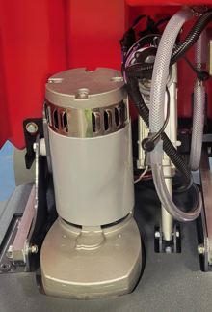

  - Pop the rubber grommet out of the TDS box and pass the 4 pin terminal from the main wire harness through it and into the box. Connect it to the proper terminal on the board. Ensure that the jumper on the board has been removed.

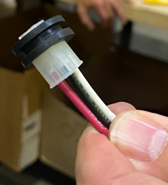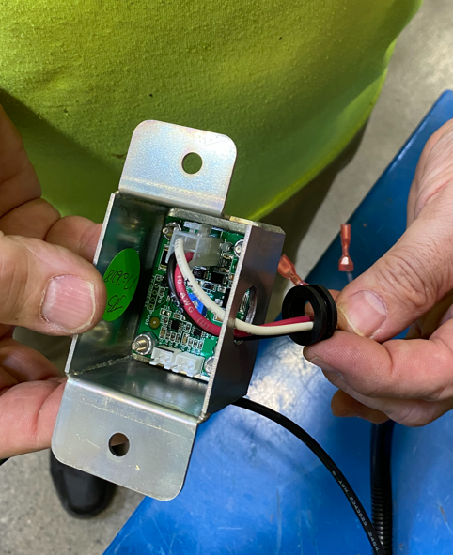
  - Feed the ends of the probe wires through the hole in the bottom of the TDS Board box. Connect the probes to the proper terminals. Put the grommet back into the hole.

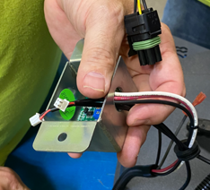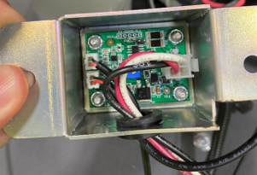

  - Attach the TDS box to the solution tank as shown using 2 screws (E29018). Ensure all of the TDS wires are bundled and routed well so they don’t kink or snag.

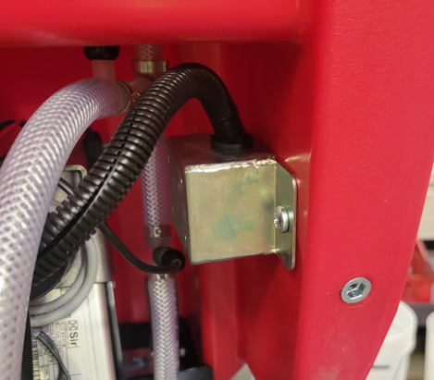

  - Install the hanger bolts for the front cover. This uses 4 spacers (E29579), 4 bolts (E81089), and 4 washers (E29403). The washer goes under the bolt head.

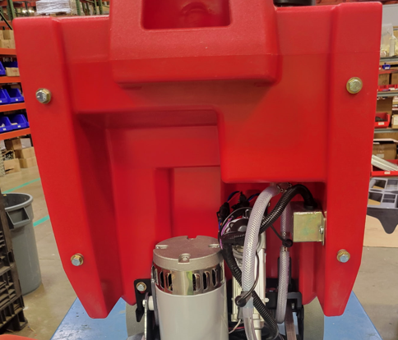
  - Attach a front fill cover (E28825). Position it into the proper location and drill 2 pilot holes using the supplied #29 drill bit. Attach the cover using 2 screws (E28761) and 2 washers (E28775). Do not overtighten.

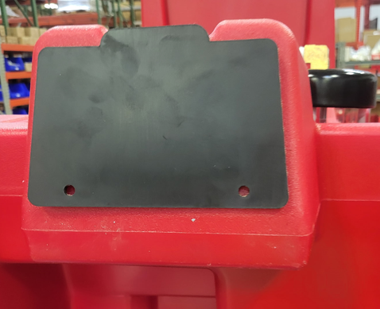

  - Attach the rear fill port cover (E28837) by positioning it into the proper location and drilling a pilot hole using the supplied #29 drill bit. Attach the cover using a screw (E28761) and a washer (E28775). Do not overtighten.

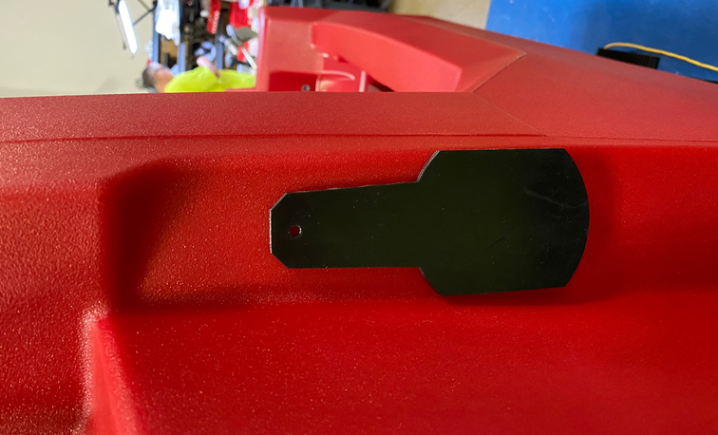

  - Stick 2 handle seals (E28823) into the location where the handle will mount. They just get stacked.
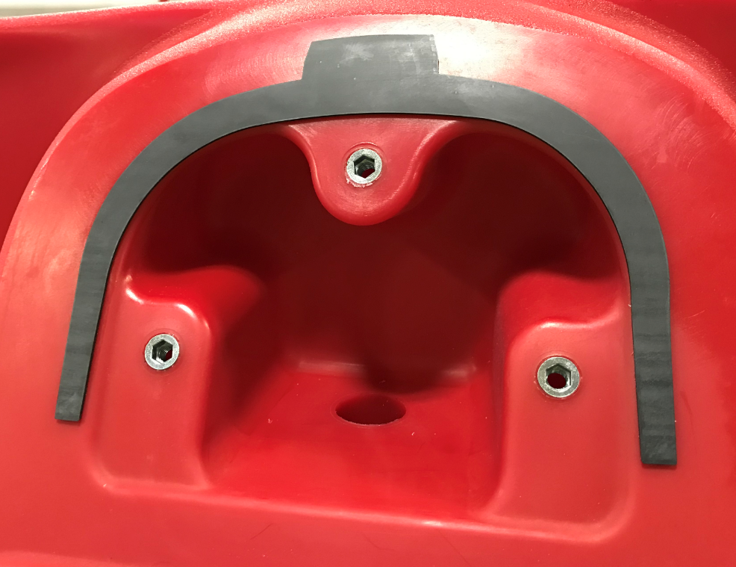
  - Attach a recovery tank hose bracket (E28712) using a button head screw (E28648).

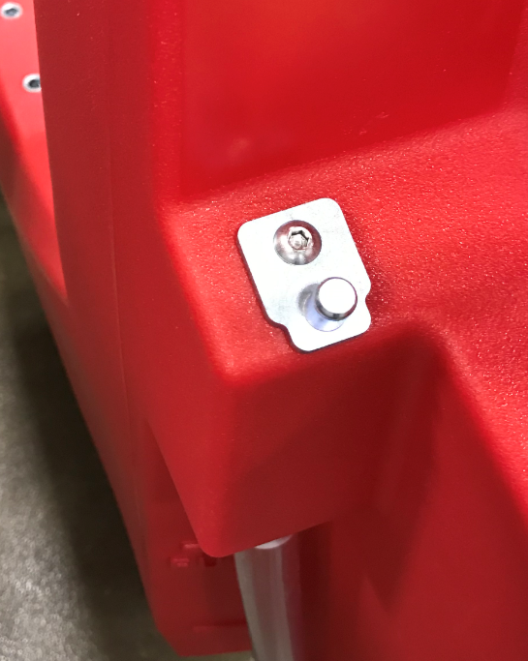

  - Install the squeegee hang bracket (E28707). Use a hex bolt (E81089), a wave washer (28765), and a flat washer (E29403). Use some Blue Loctite on the threads. The washers go behind the bracket. Do not overtighten as the bracket needs to pivot up and down.

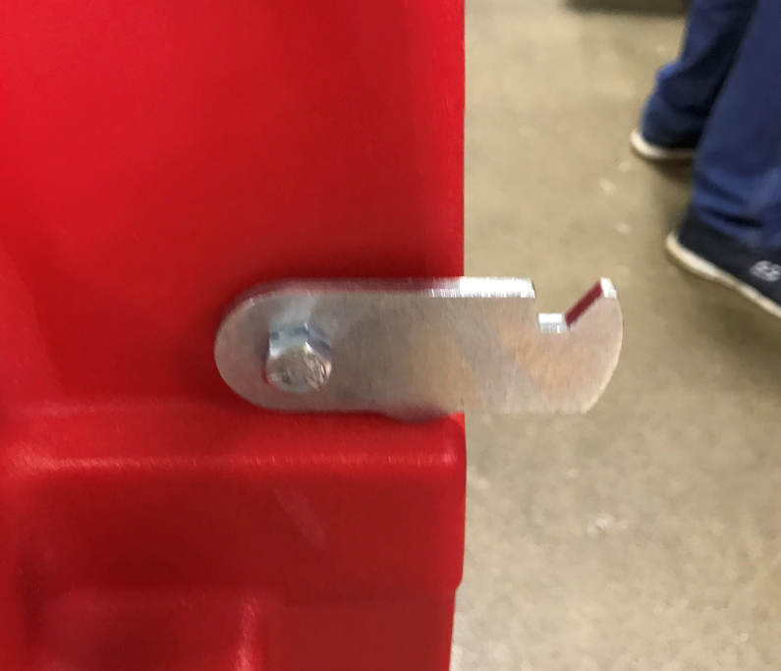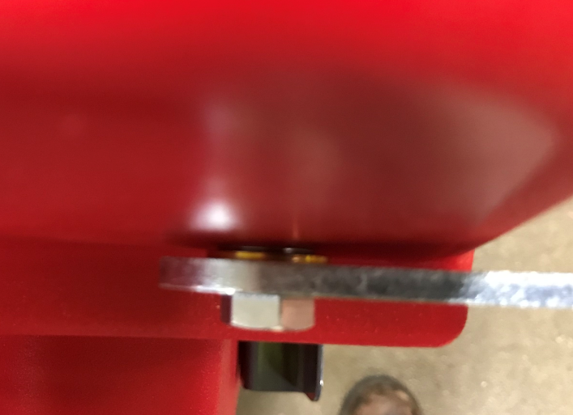

  - Mount the charger cord wrap bracket (E28737) using 2 bolts (E28648).

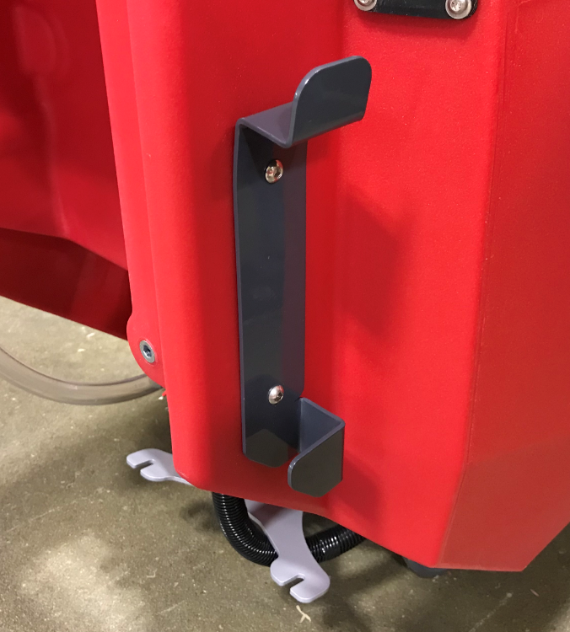
  - Take a cable guide bracket (E28714) and put a cable guide (E28715) through the hole. Attach them with a snap ring (E28722).

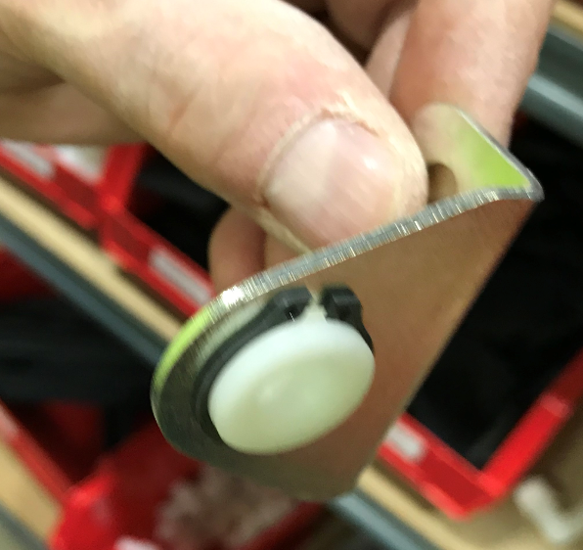

  - Attach the bracket to the tank using 2 bolts (E28648).

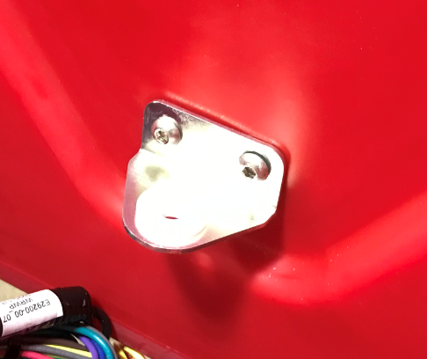

  - Feed the handle of the squeegee lift lever (E28909) through a squeegee lever guide (E28756). Slide a squeegee lever grip (E28721) into place.

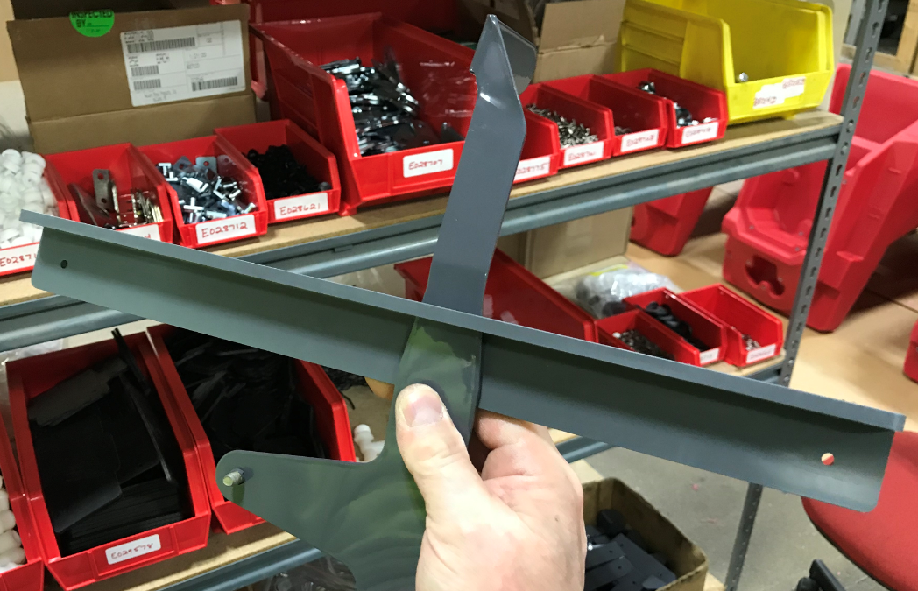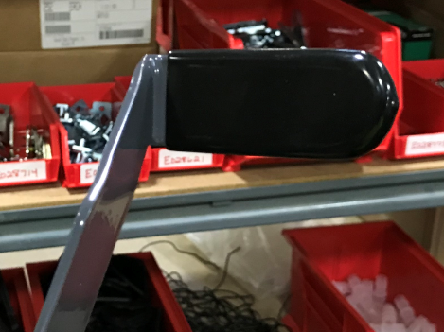
  - Attach the lever to the solution tank using a nylon washer (E28719) (Between the lever and the tank), a squeegee lever bushing (E28718), and a flat head screw containing Blue Loctite. (E28763). Ensure that the nylon washer stays over the end of the bushing during tightening. If it comes off it will get pinched against the tank and not work properly.

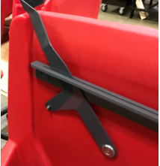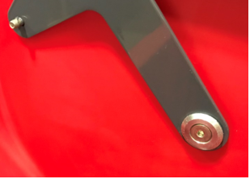
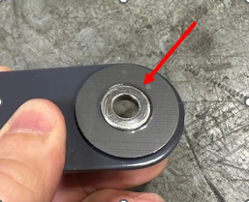

  - Attach the squeegee lever guide in place by first drilling pilot holes with the #29 drill bit provided. Ensure it is level. Position it so that there is about ½” clearance between the arm and the bottom of the bracket. Use 2 screws (E28761) and 2 washers (E28775). Ensure the lever can pivot easily.

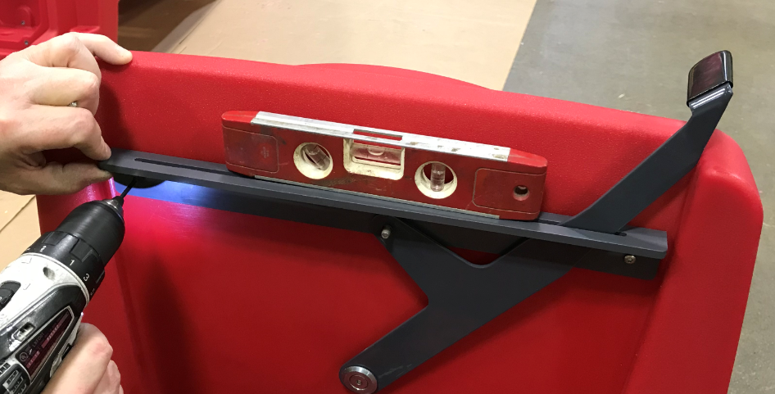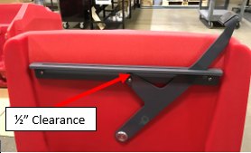
  - Attach the eyelet end of a squeegee lift cable (E29014) onto the threaded stud using a nylock nut (E29565). Ensure it can still pivot by not tightening the nut completely.

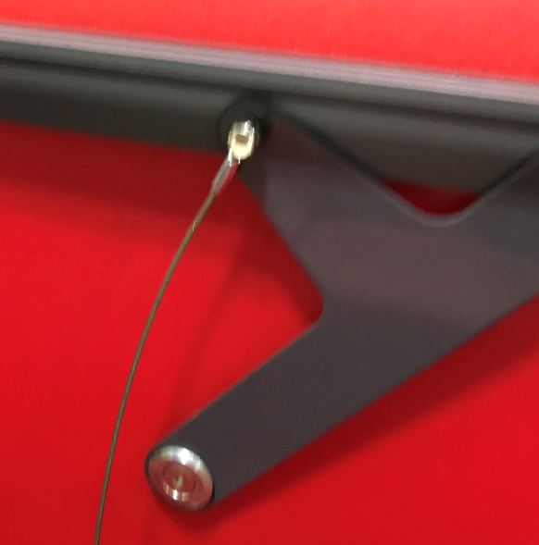

  - Feed the threaded stud end of the cable through the cable guide bracket.

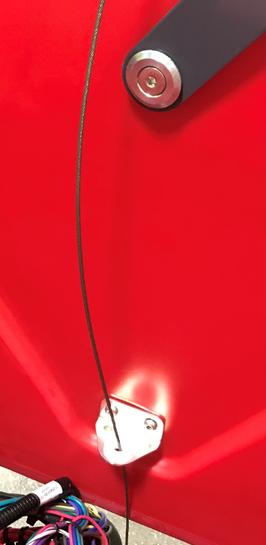

  - Attach the end of the squeegee lift cable to the pivot. Thread a hex nut (E29565) up towards the top of the stud. Place a flat washer (E28617) over the threaded end and feed the stud through the hole on the squeegee mounting bracket. Then place a spherical washer (E28717) over the end of the stud and attach everything using another flat washer (E28617) and nut (E29565). Thread the nut up enough so that the assembly can still pivot properly.

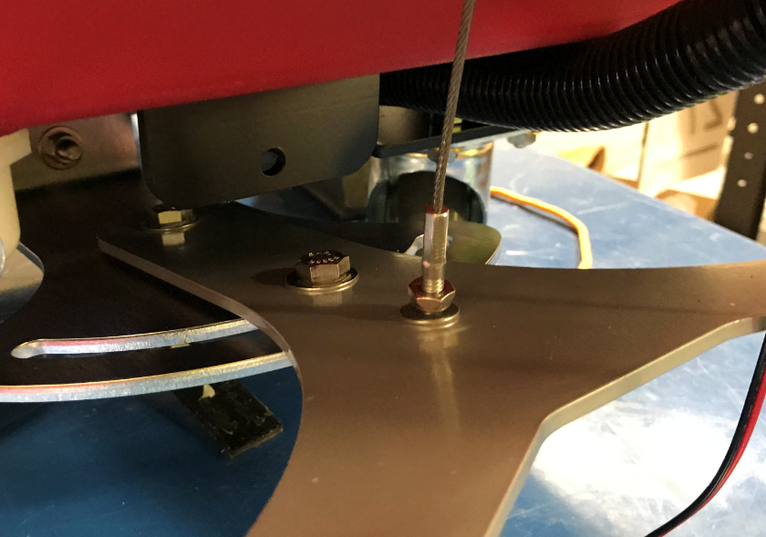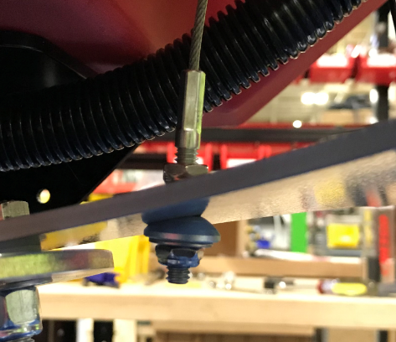

  - Take a head lift pedal guide (E28870) and attach a microswitch (E28000) in the orientation shown using two screws (E28762), two external tooth lock washers (E28821), two flat washers (E29368), and two lock nuts (E28770).

Pictures Inserted Here

  - Fasten the pedal guide to the solution tank using two bolts (E81089) and two washers (E28622).
  - Place two batteries (E28887/E11767 for wet / E88330 for AGM) into the battery compartment in the orientation shown.

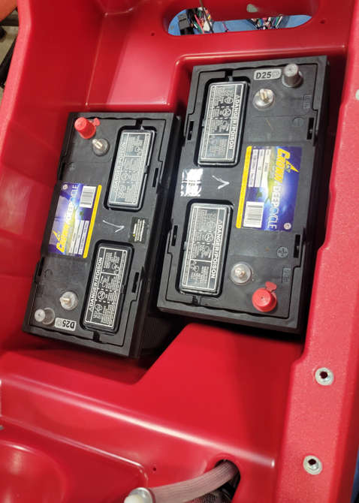
  - Assemble a red boot (E12543) onto one of end a battery cable (E29203). Attach it to the battery pack as shown on the side away from the operator. Attach a negative cable (E29022) to the main negative terminal shown.

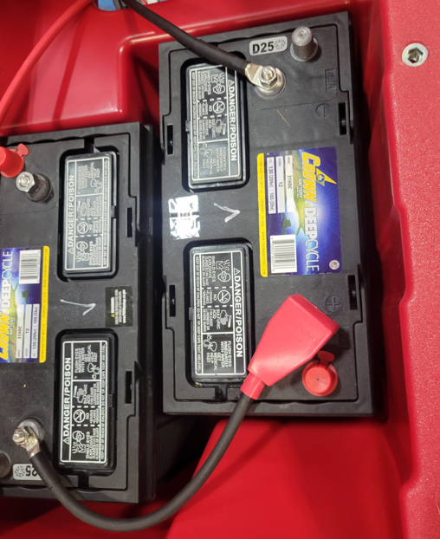

  - Take the 5” positive battery cable (E29204) and attach it to a fuse holder (E28974). Ensure the small hole on the cable goes to the fuse holder. Attach the other end of the fuse holder to another positive cable (E29023). Again, ensure the small hole on the cable goes to the fuse holder. Install the fuse (E28975) into the holder, tighten the nuts, and snap the cover in place. Finally, put a terminal cover (E12543) over the end of the 5” cable.

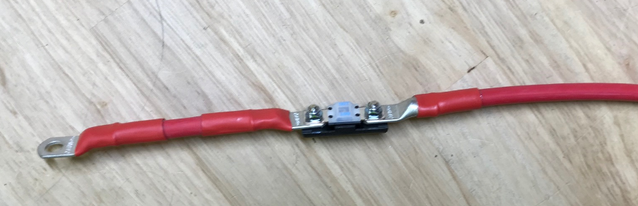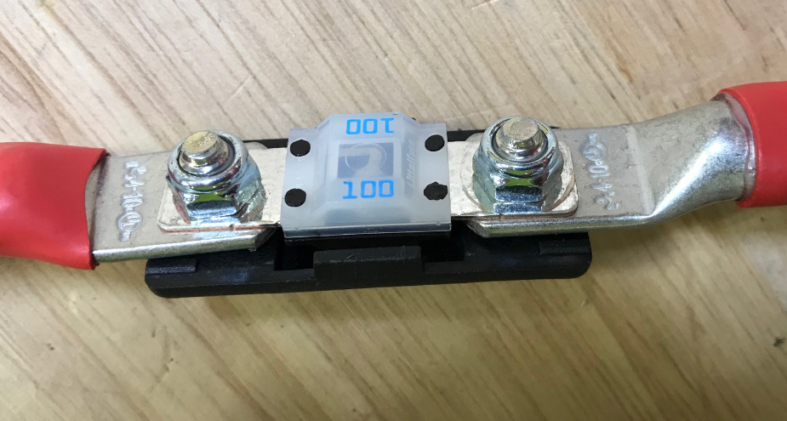

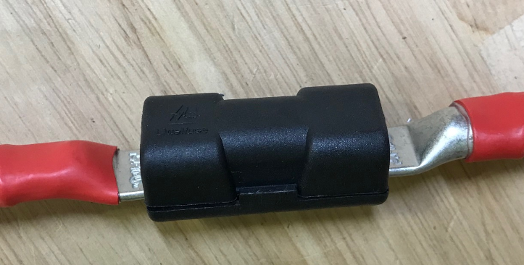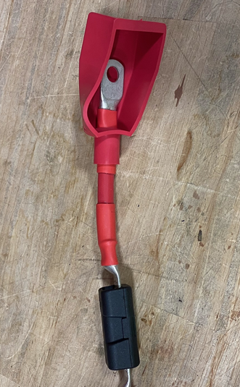

  - Lay this assembly as shown in the photo with the boot oriented on the battery side. This and the negative cable will be routed and connected to the main panel.

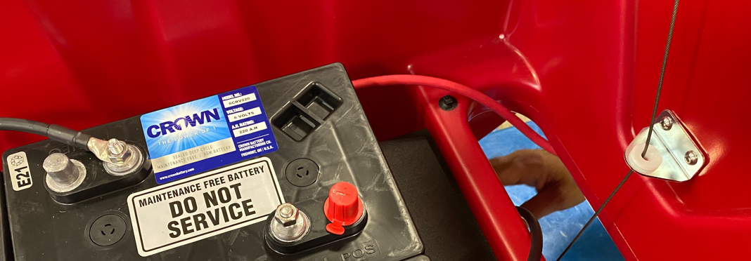

  - Get an assembled inner electrical panel (SOP EQ 145). Attach it to the solution tank using 2 screws (E28648) and 2 toothed washers (E29446). It will only fit in one direction as shown.

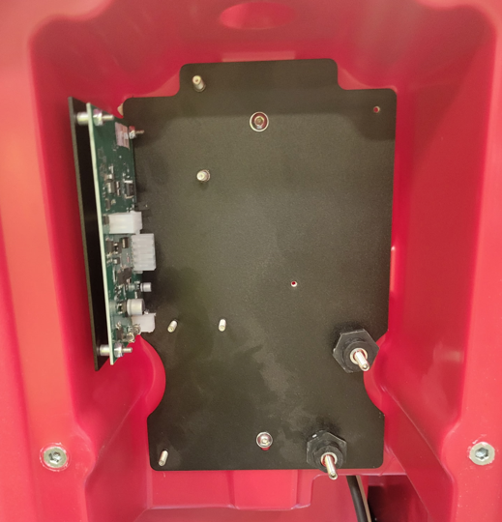

  - Replace the traction drive control board with a pad assist control board (E28810).
  - Hang the positive battery cable that was just assembled to the positive panel standoff. Use the end furthest from the fuse. Ensure the other end stays in the battery compartment, but to not attach it. Place it beside the batteries so it does not inadvertently touch a terminal.
  - Hang the negative battery cable to the negative panel standoff. Attach the end of the cable with the small hole. The other end can be routed into the battery compartment and attached to the proper negative terminal.
  - Hang the charger harness (E28979) ends to the appropriate panel standoffs. Note the location of the + and – wires.
  - Attach the + and – terminals from the main harness to the appropriate standoffs on the panel. Fan the terminals out so that they tighten up properly. Unless there are options on the machine, the nuts on the studs can be tightened. Use a nut (E28853) and a washer (E28617) on each one. Use a torque wrench to tighten to 8 ft-lbs. Tug on the wires to ensure they do not move. When using the torque wrench, only hold on the handle as shown to get an accurate reading.

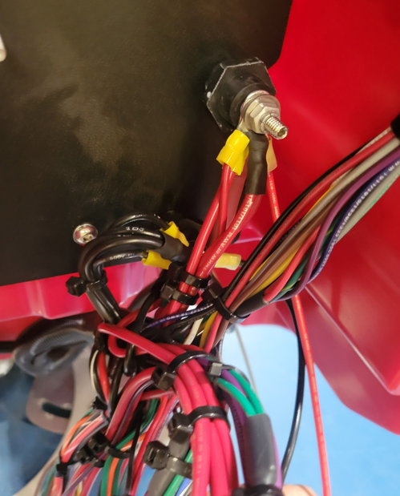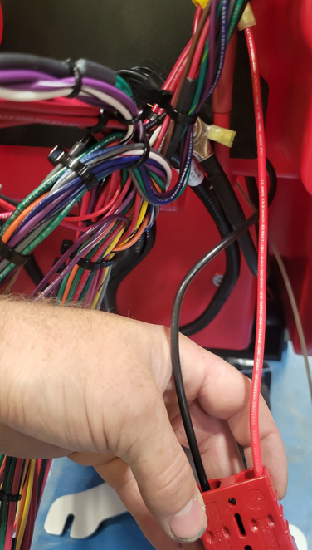
Charger
Harness
-
+

  - Feed the portion of the main wiring harness that goes to the vac motor into the battery compartment as shown.

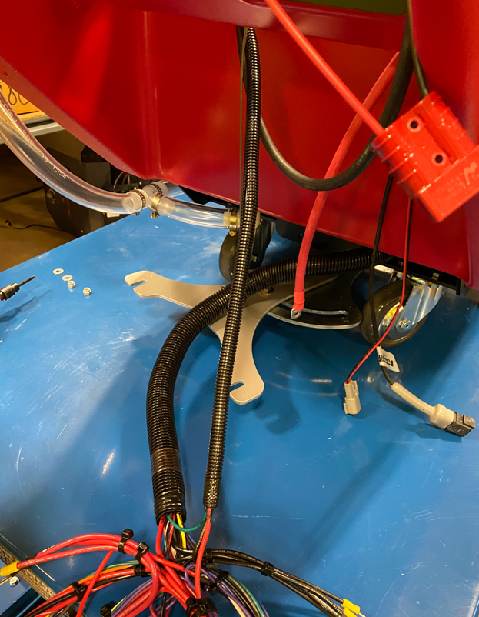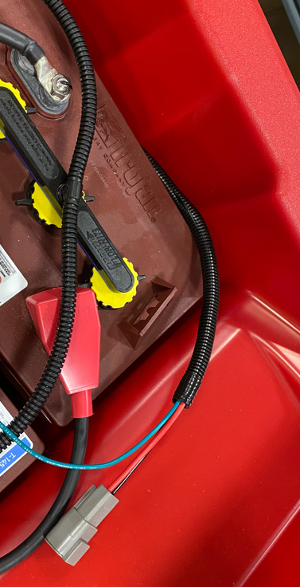

  - Feed the wires for the console/bail through the hole into the upper cavity.

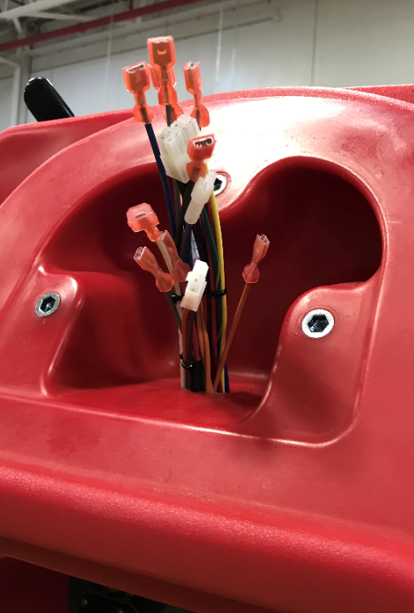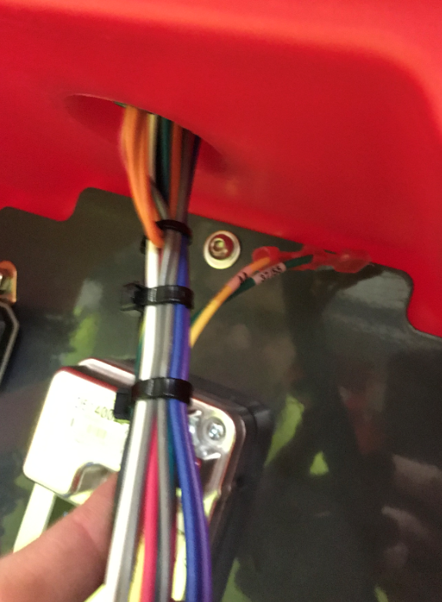
These 2 wires always stay in the lower compartment

  - Take a bail assembly (SOP EQ 090) and connect the microswitch to the appropriate wires from the main harness up in the handle attach area of the tank. The photo shows the correct sequence. Wire numbers are noted in the photo.

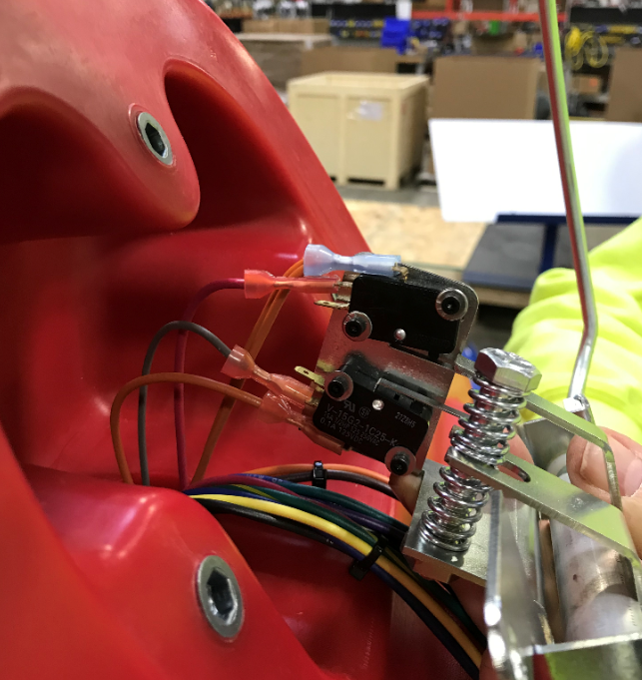
63A
8
62
63&63A
  - Attach the bail assembly to the solution tank using 2 bolts (E81089) and 2 washers (E81062). Ensure the wires are coming out of the appropriate side of the bracket as shown.

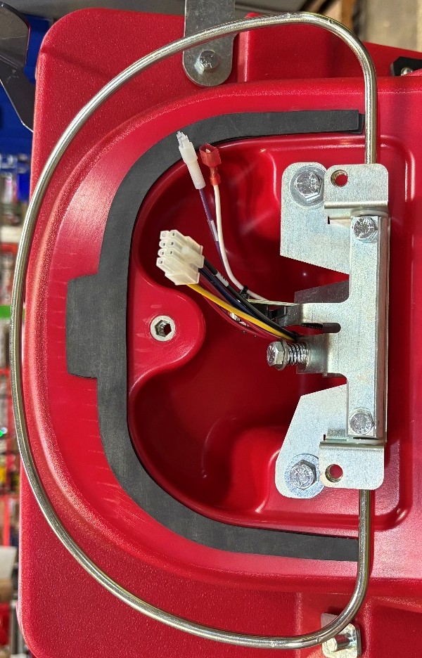

  - Get a handle assembly (SOP EQ 110) and fasten the plastic handle to the tank using 3 bolts (E81089) and 3 washers (E81062). Use Blue Loctite on the bolts. Make sure to not pinch any of the wires on the harness.

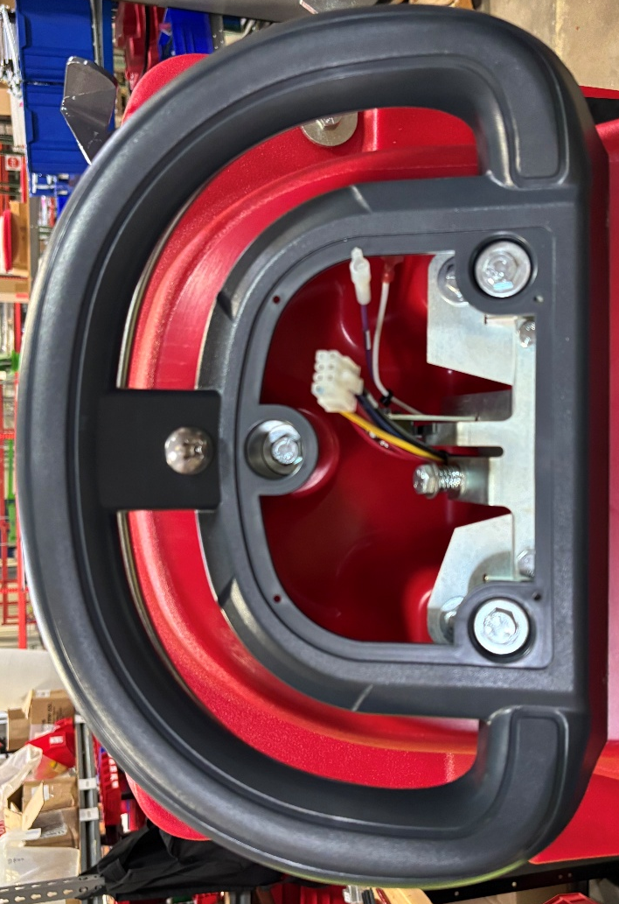

  - Take an appropriate console panel (SOP EQ 091) and connect the 8-pin connector from the main harness into the BDI. Verify the BDI has the proper setting for the battery type. It should be set at “1” for wet batteries. If the machine has AGM batteries, change the arrow to “4”.

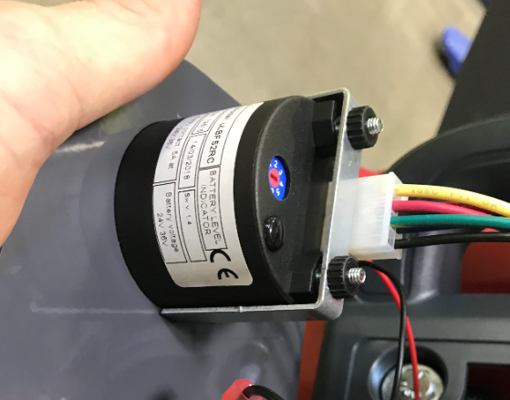

  - If the machine has Solichem, connect the two wires from the Solichem LED to the main harness. These connectors are error proofed. The wire numbers from the harness are shown.

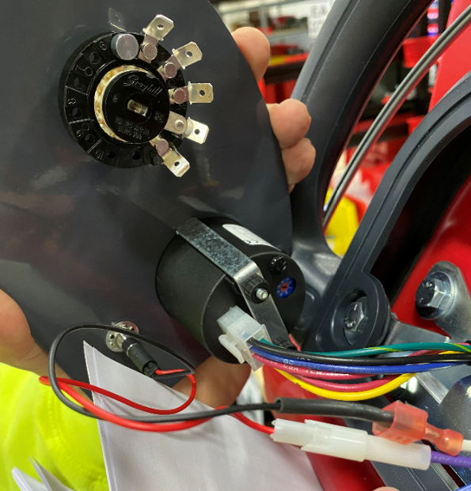
Purple-65A
White-71

  - Mount the console panel to the handle using 4 screws (E29334). Tighten by hand and be sure not to overtighten or the decal will wrinkle. Pull on the panel to make sure it doesn’t move.
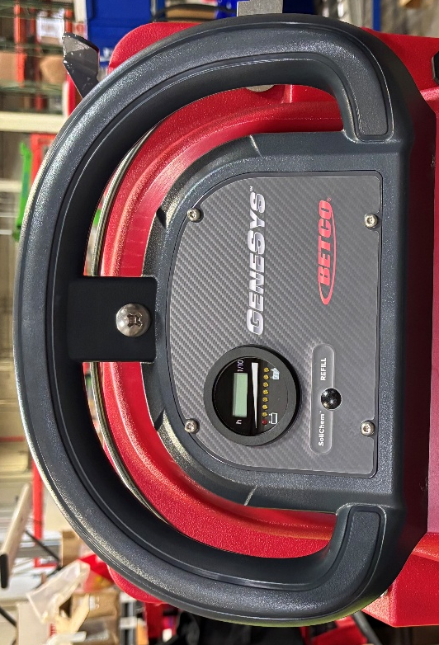

  - Connect the appropriate connectors on the main harness to a Contactor (E28924). The hardware is already on the contactor. Use a ratchet/nut driver to ensure the nuts are fully tightened. Mount the contactor to the panel using 2 nuts (E28618). Pull on the wires to make sure they don’t move.

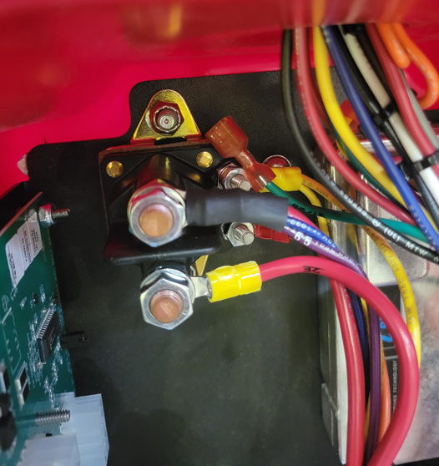
33
4/4B
12/36/82A
2E

  - Mount the relays from the main harness to the appropriate studs on the panel with hex nuts (E29366) as shown. Ensure they are tight. The largest relay goes on the top right.

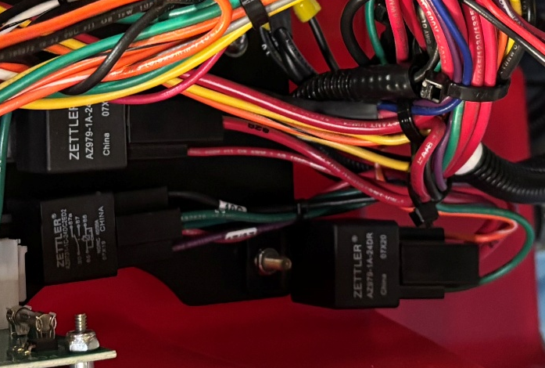
  - Connect the appropriate connectors from the main harness to the control board. There are 3 terminal blocks to plug in (12 pin, 10 pin, and a 4 pin).

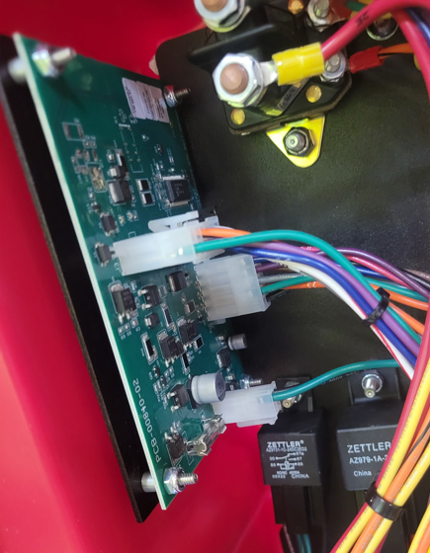

  - Take a back panel (EQ SOP 137) and prop it behind the machine (with something like a bucket) to make it easier to wire it up.
  - Connect the charger interrupt connector from the charger to the appropriate connector on the main harness.

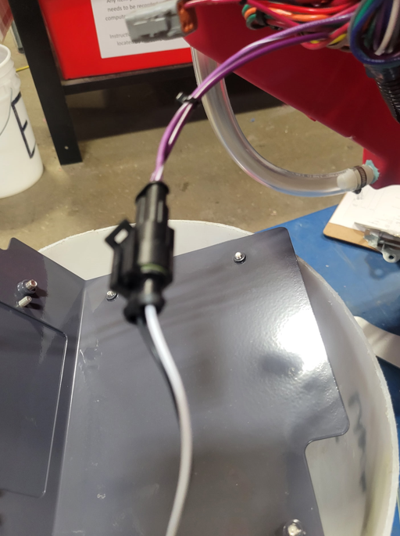

  - Connect the Andersen connector from the charger to the charger harness that was mounted to the inner panel.
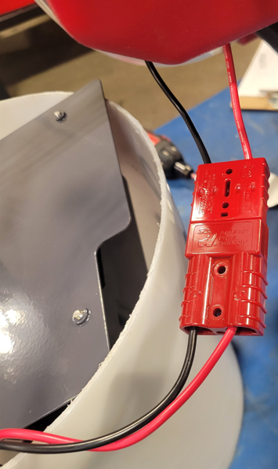

  - If the machine is equipped with SoliChem, connect the appropriate connectors from the main harness to the TDS Switch. It does not matter which switch goes to which terminal.

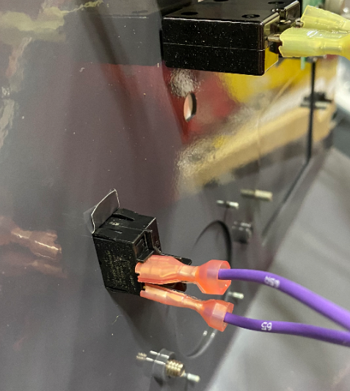
65 & 65A

  - Connect the appropriate connectors from the main harness to the circuit breakers on the panel. The lengths and/or how they are held by the wire ties should give the order. If not, use the wire numbers shown below. Right or left terminal does not matter.

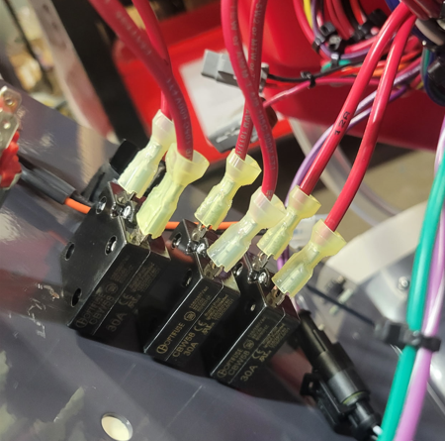
12 & 12A
32 & 32A
2I & 42
  - Connect the Key Switch to the main harness. It does not matter which wire goes to which terminal.

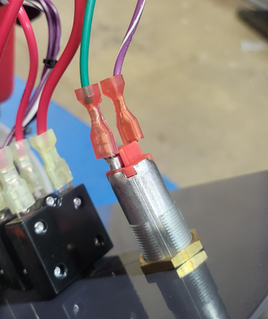
5/15/77
57

  - Connect the pad release button to the appropriate connectors on the main harness. It does not matter which terminal goes to which wire.

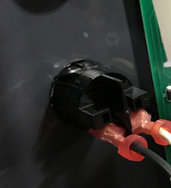
10C
29

  - Connect the solution potentiometer to the appropriate connector on the main harness. It is a 2 pin connector.

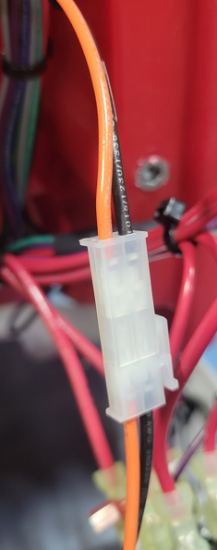
10R
23
  - If the Wet Battery Protection Option is needed. Refer to section 6.01 in SOP EQ 111 (Genesys MSS Final Assembly Options).
  - Mount the panel to the tank using 4 washers (E28617) and 4 screws (E28648). Be careful as they can strip. Make sure all wires are tucked inside on the cavity and don’t get pinched. The main portion of the harness should pass through the cutout in the panel.

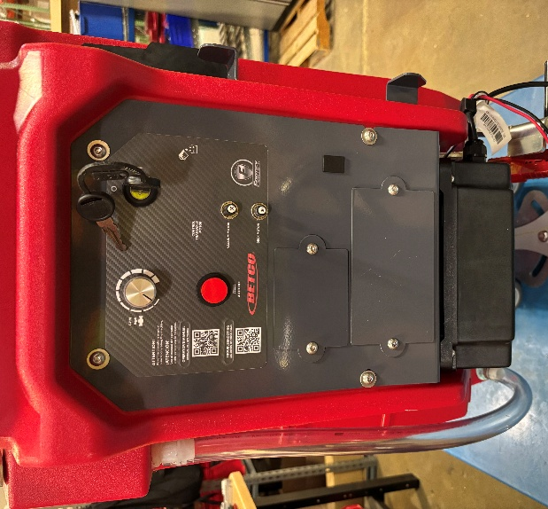

  - Connect the charger extension cord (E28704) to the charger and wrap the excess around the cord wrap.

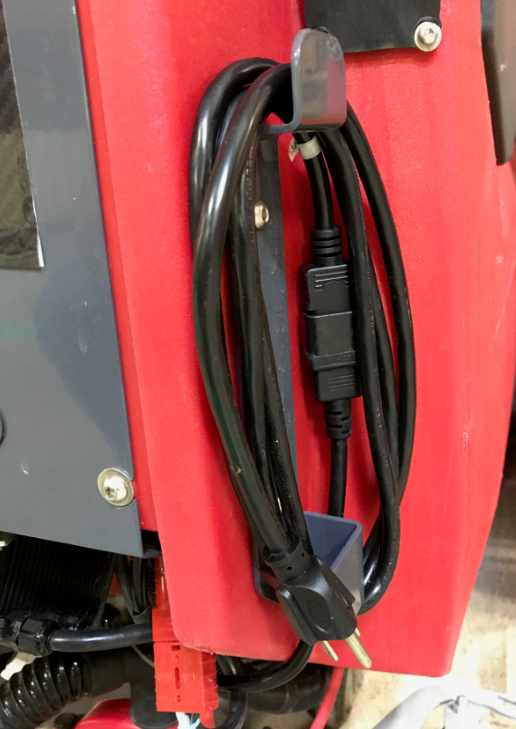
  - Attach a 30” squeegee to the machine (SOP EQ 097).

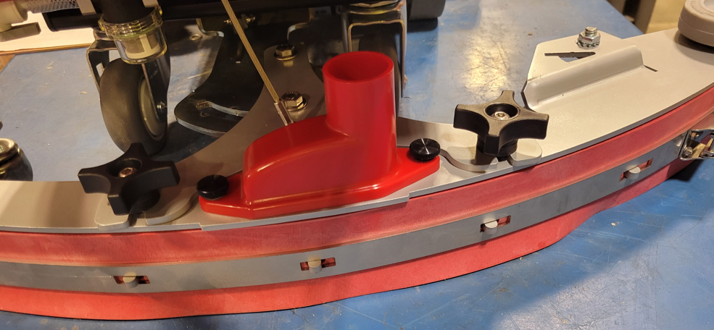

  - Get a recovery tank (SOP EQ 100) and place it near the machine using the cart shown. This will angle it to allow it to be attached easier. Bring the tank over to the machine and adjust the build cart height to allow the first hinge to be attached.

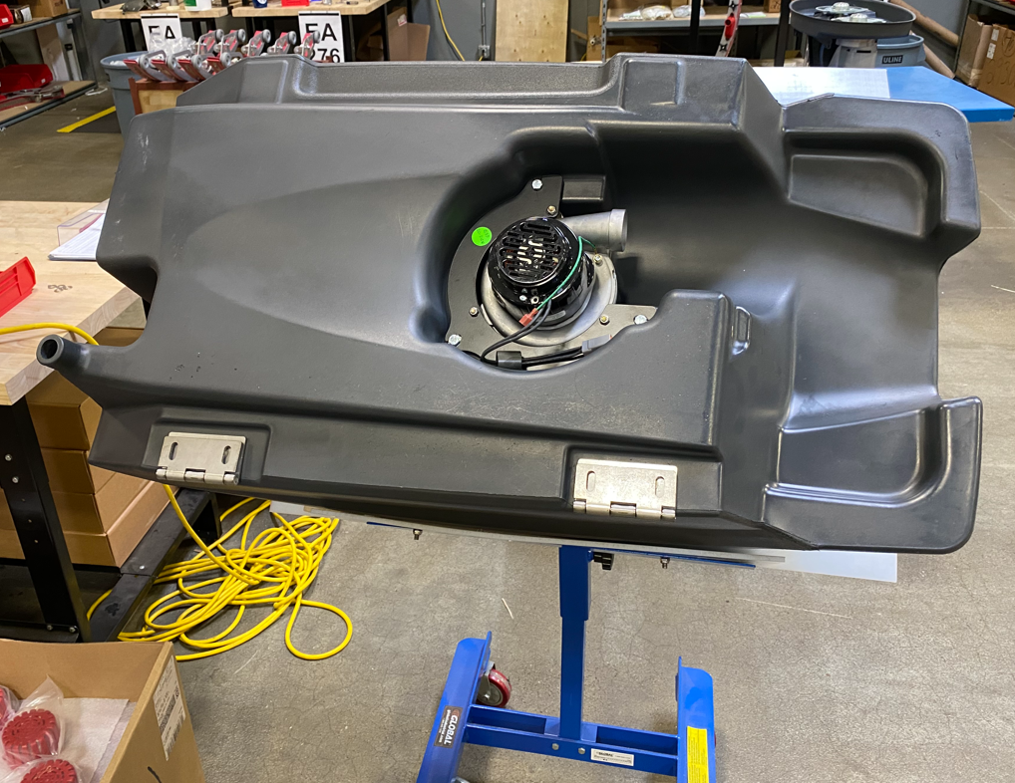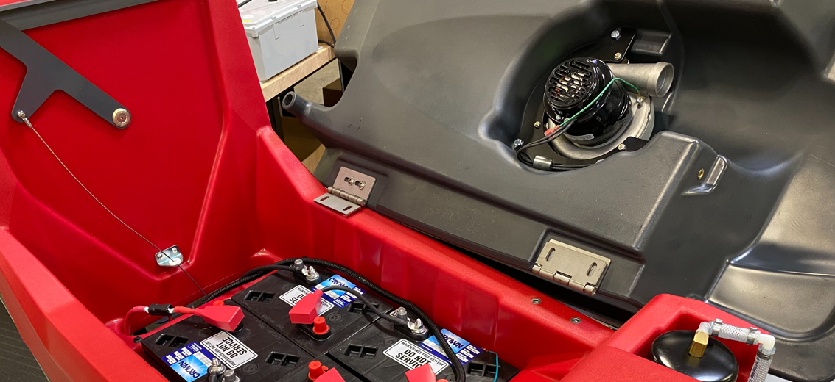

  - Attach the first hinge using 2 flange bolts (E29569). Once that is done, adjust the build cart height to allow the 2nd hinge to be attached. Use 2 more flange bolts (E29569) to attach.

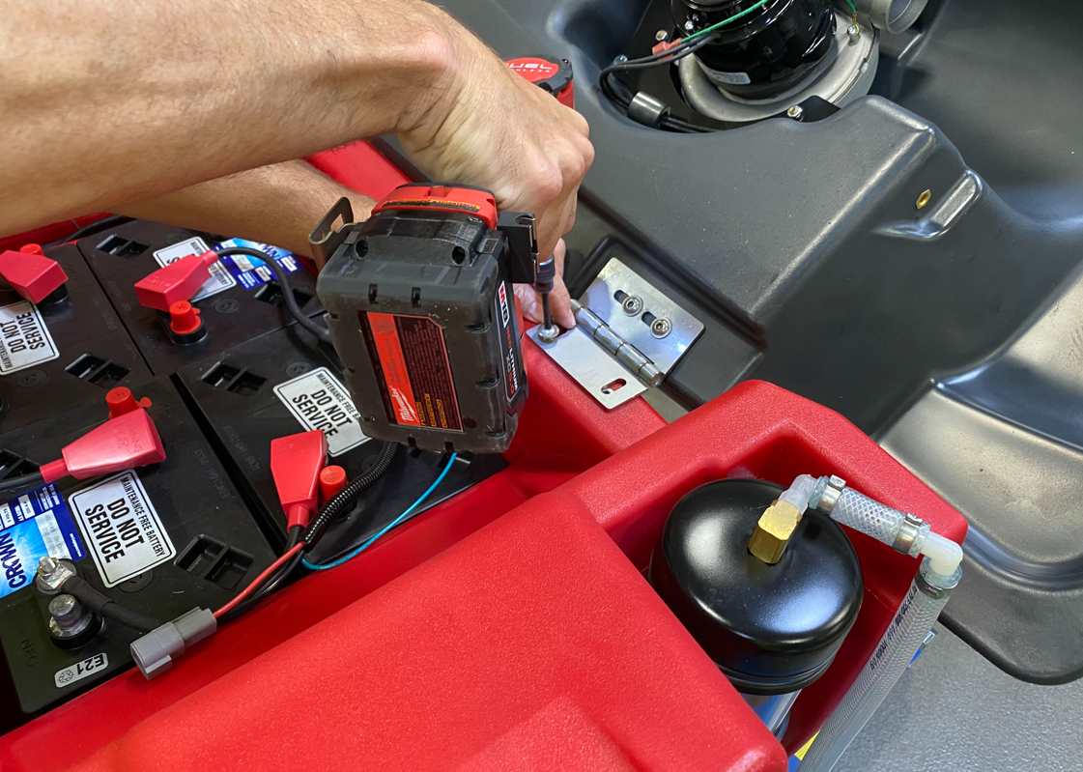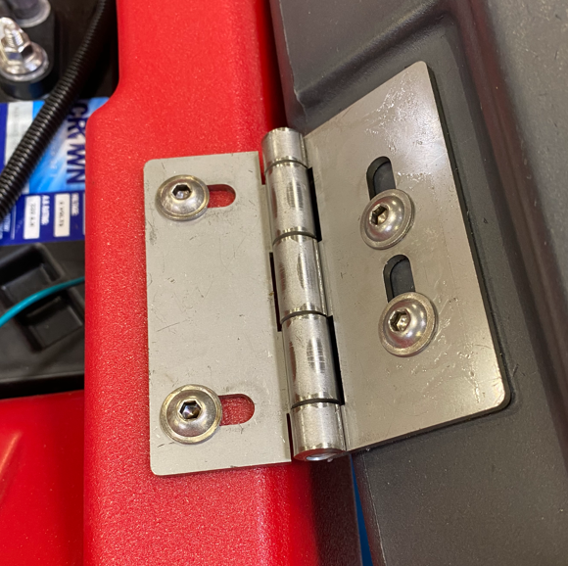
  - Close the recovery tank lid and verify that it is centered on the machine. If not, open it back up and readjust by loosening the screws and move it. Continue until it is centered. **There is nothing keeping the recovery tank from falling all the way open. Ensure either the cart is in place or there is another person helping hold it open if adjustment is needed.**
  - Attach the solution and recovery tanks using a recovery tank cable (E28760). Attach each end of the cable using a hex bolt (E29392) and a hex nut (E12524). Thread the bolt in part way, then tighten the nut to the tank to ensure the cable end can pivot. **Note-Ensure that the cable loops down into the solution tank cavity as the lid is closed. If it loops upward it could loop around the HEPA filter and tear if off. If it loops up, either put a kink in the cable or turn one of the ends of the cable 180°.

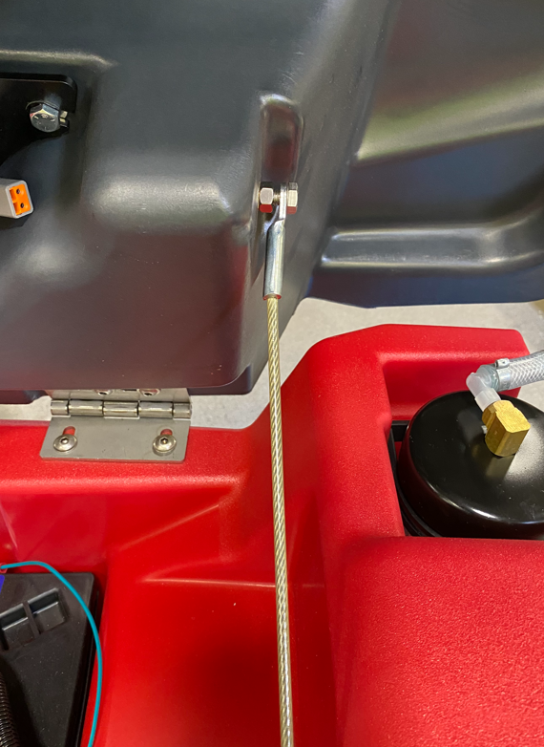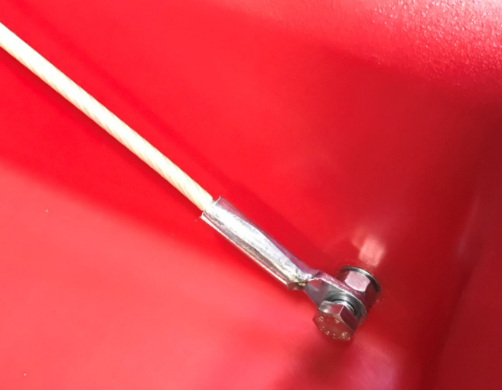
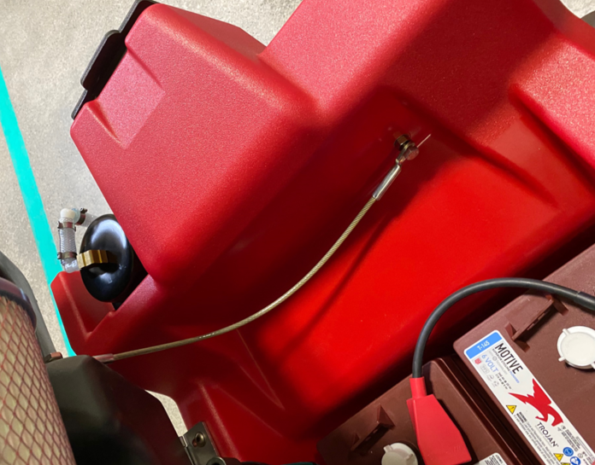

  - Install a HEPA filter (E28994) onto the vac motor using a worm clamp (E28755). Use the provided torque screwdriver to tighten the clamp to 15 in-lbs of torque.

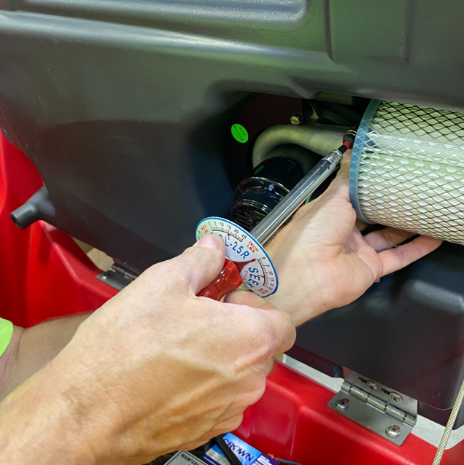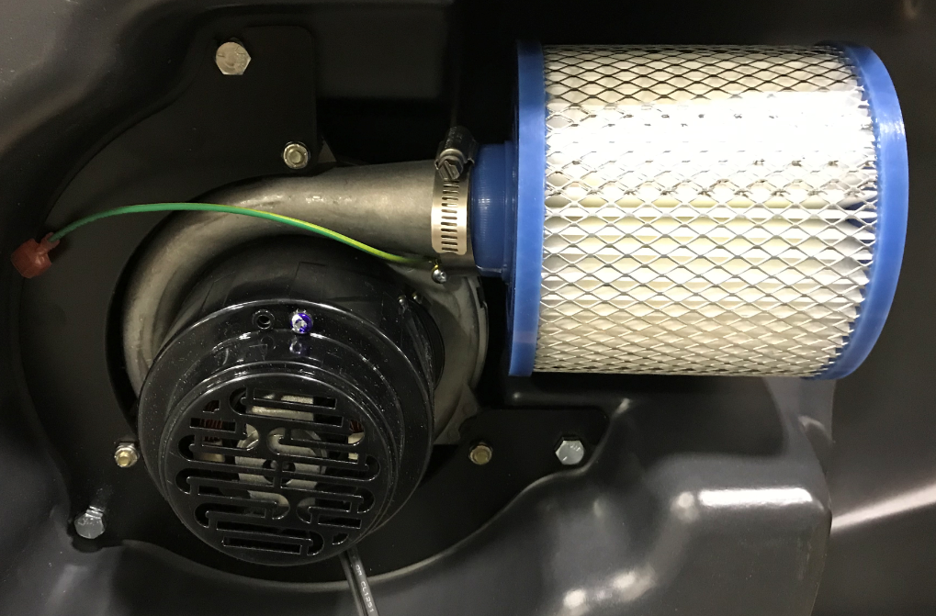
  - Connect the vac motor and the ground wires to the main wire harness. Clean up the wiring in the tank using 2 zip ties (E83523).

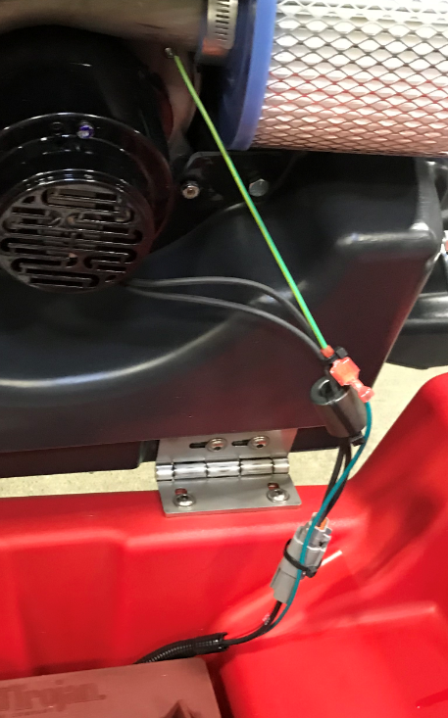

  - Push 2 zip tie mounts (E28621) into the holes on the solution tank. Use a zip tie (E83523) in each to secure the loom for the vac wire.

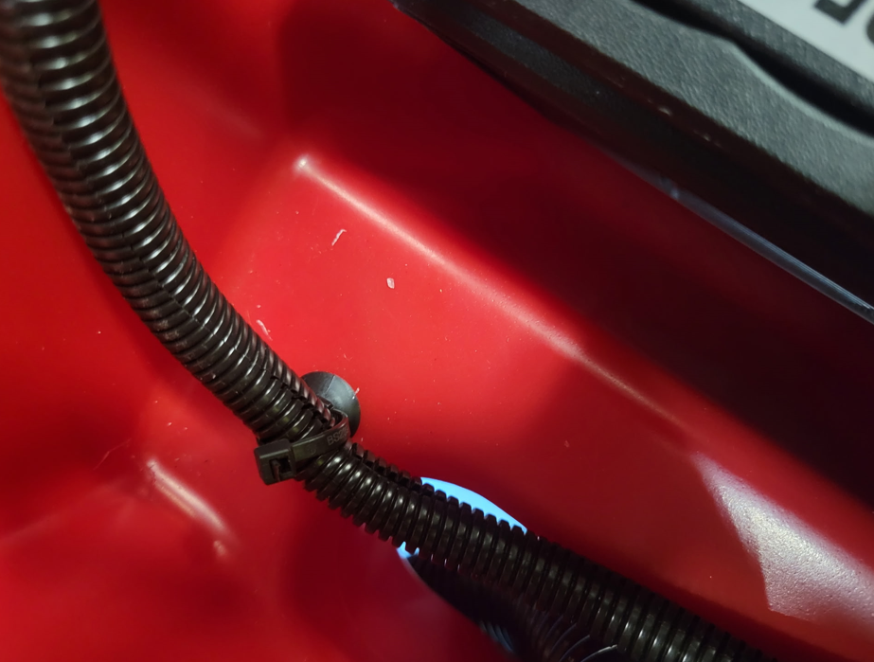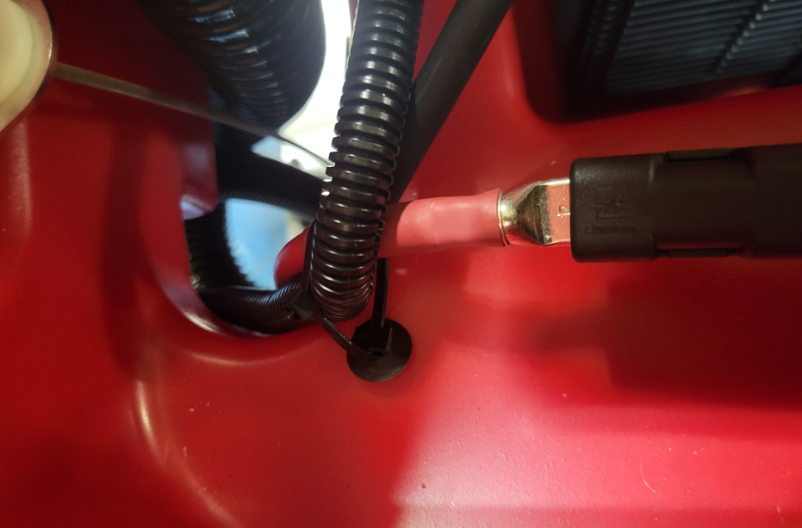

  - Take a squeegee vac hose (E28998) and press the angled end onto the barbed fitting on the back of the recovery tank.

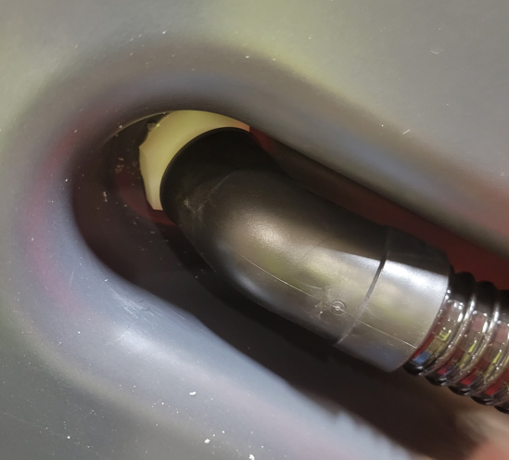

  - Take a recovery tank drain hose (E28921) and attach it into the drain port of the recovery tank by using a worm clamp (E83966).

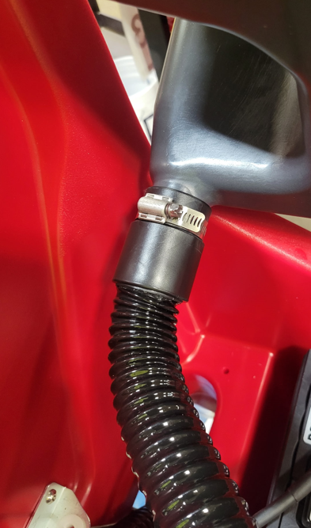

  - Route the 2 hoses out of the battery compartment.

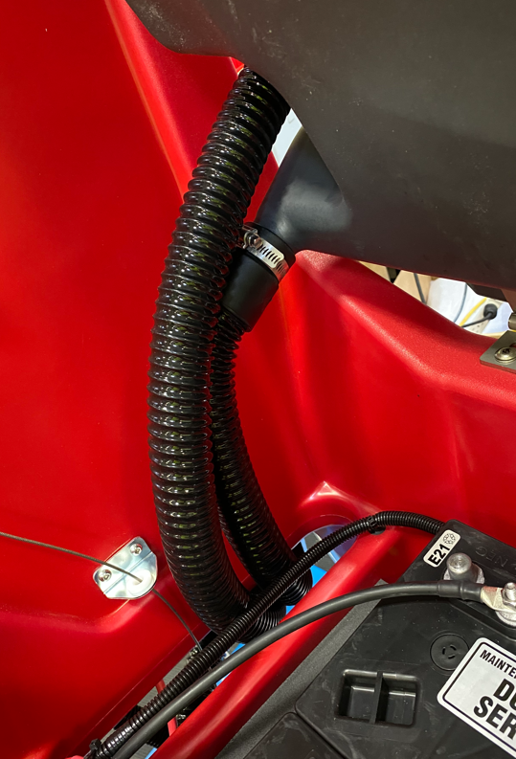
  - Connect the end of the squeegee vac hose to the port on the squeegee. Hang the end of the recovery tank drain hose as shown.

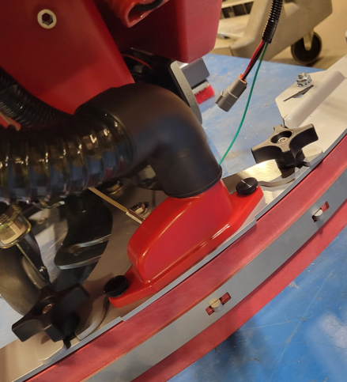

  - Take a recovery tank lid (E28885). Put a little blue silicone gasket maker into the groove in a couple points to hold the gasket in place. Be sure to put some under each end of the gasket. Cut a 63” length of gasket (E29528) and install it into the groove. The edge with the rounded bulb goes towards the outside of the lid. Trim as needed to get the ends to line up.

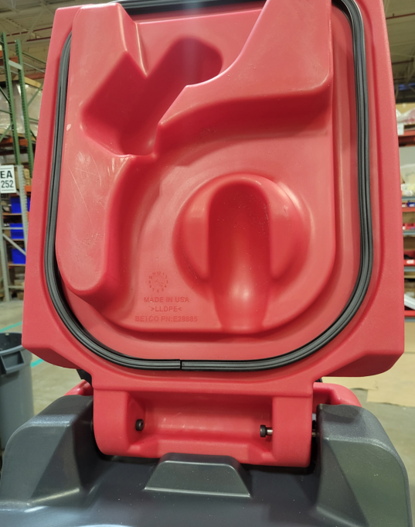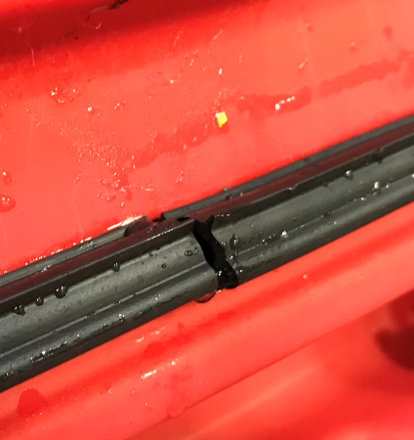
Ends meet here

  - Attach the lid to the tank using 2 shoulder bolts (E29558).

  - Attach a debris tray (E29525) to a puck holder (E29561) and place them into the pocket in the tank.

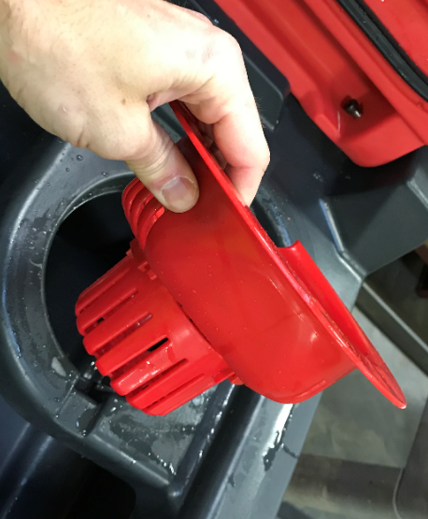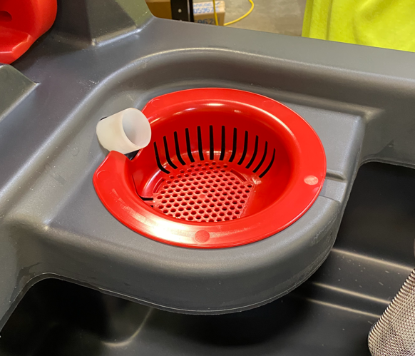

  - Close the recovery tank lid.
  - Ensure the key is in the “OFF” position. Connect the main positive battery cable to the battery terminal. Verify that the BDI comes on. If it does not, there is an issue that you need to troubleshoot before moving on.
  - Do a quick functional check of the unit to make sure all of the functions work prior to sending the machine to QC.
    - Verify vac motor turns on and off as required.
    - Ensure that the brush motor does not turn on when the scrub head is in the up position.
- References (optional section as needed)

- Training Guide

Functional Training Groups Requiring Training
Equipment Assembly Group

- SOP Change Control

Date of Change | Reason for Change
Rev 01 – 6/12/2026 | This is the first version of the S.O.P. hence there are no revisions to this document.

Approvals

Submitter/Author Approval:__________________________________ Date:______________________

Management Approval:______________________________________ Date:______________________

QAU Approval:_____________________________________________ Date:______________________

